In your AP module select payments



* (in Dropdown menu) select “check reconciliation”

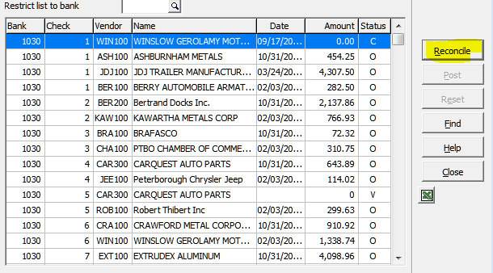

Find the cheque that you are looking for and click Reconcile.

In this window make sure you have the right cheque, change the status to “reversed” and then click OK.

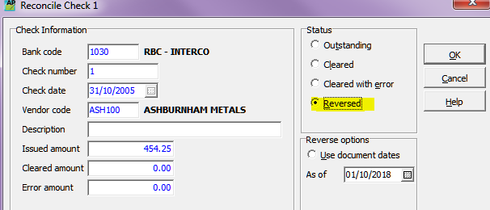

Back in the list screen you should see the status of your cheque changed to O->R.

If that’s what it looks like, then you can post.

Right reversed across the cheque and file it with the vendor.

